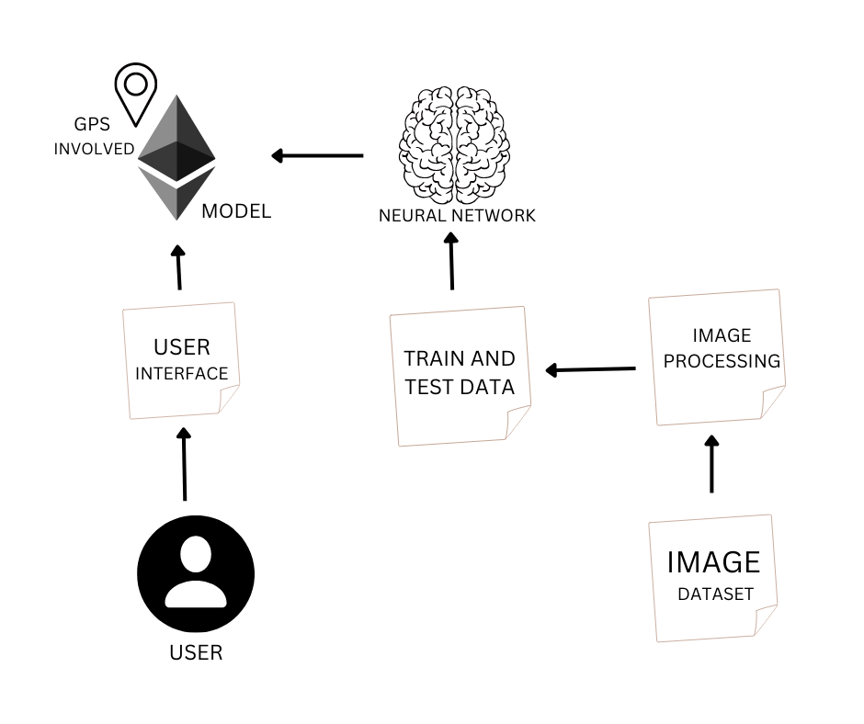**FIRST MILESTONE**

PROJECT THEME:

* This project will be helpful for the people with vision disabilities.
* This device the GPS and sensors to detect the objects and people.
* This device can able to detect the trees and other environmental objects.
* The faces of the well known persons can be saved in this device so it can be able to detect that persons.
* The strangers will be detected and information will be given to the user.